ENMAT101 Engineering Materials and Processes

Laboratory 3: Torsion Test
Like Bending, Torsion is an important type of loading that can produce critical stresses in engineering applications. Under torsion, SHEAR stresses are produced. The stiffness under shear stress is called the MODULUS OF RIGIDITY G.(MPa) It is also called Shear Modulus.
In this laboratory, we will determine the Modulus of Rigidity of the metal rod.

AIM
- Shear Stress
- Modulus of Rigidity G
- Compare these values with published data (e.g. Matweb)

LABORATORY PROCEDURE
Before starting the lab, calculate the maximum load that can be applied to the rod, assuming a limit of 75MPa (safe shear stress in brass). See Materials_General.htm for our list of material data (Same as available during Tester). This is to make sure we do not break the rod.
- Measure diameter and length of rod, radius of pulley, mass and any other relevant data. Reset angle.
- Add mass and measure angle.
- Repeat step 2 until enough measurements are taken to draw a graph. You will need about 20.

LABORATORY REPORT
In this laboratory, we will determine the Modulus of Rigidity of the metal rod, and verify that the angle of deflection corresponds to what we would predict from equations. You must do your working in Excel.
- Prepare a report, describing the purpose of the experiment, the equipment and setup used and the results obtained.
- Using the following equations, calculate the shear strain and shear stress for each increment. Tabulate the stress and strain values.
Rod Diameter = .................... +/- .................. mm
Load (kg) > Weight (N) > radius > Torque (Nm)
Angle of twist > radians. (To convert degrees to radians: Radians = Degrees * p /180
Shear Stress & Shear Strain (These are needed for you graph)
- Using the vertical axis for shear stress and horizontal axis for shear strain, plot stress -strain diagram.
- Determine the shear modulus (G) from the slope of the straight line.
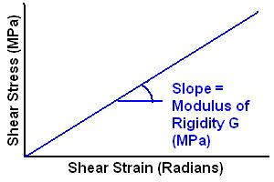
- Compare your result with the published value of the shear modulus. Calculate the % error using the error analysis rules. Make sure you include all the possible sources of error (apart from silly mistakes like mis-reading. These errors should be discovered and eliminated)

NOTES: TORSION TESTING: Finding G
Like Bending, Torsion is an important type of loading that can produce critical stresses in engineering applications. Under torsion, SHEAR stresses are produced. The stiffness under shear stress is called the MODULUS OF RIGIDITY G.(MPa) It is also called Shear Modulus.
In this laboratory, we will determine the Modulus of Rigidity of the metal rod.
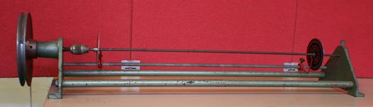
Torsion Testing Rig

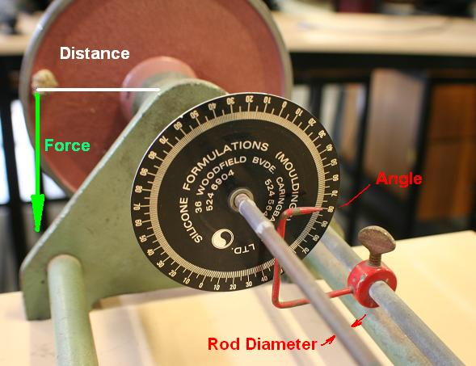
Calculating Torque Applied

Torsion Theory
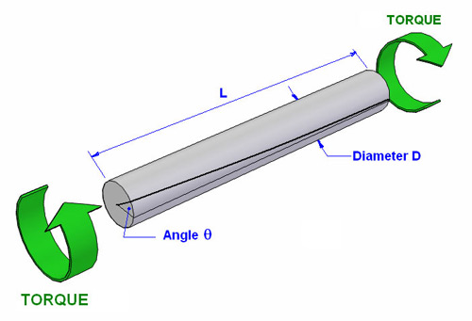
Shear Strain: ε _{s} = r θ / L  Shear Stress: τ_{s} = T r /J  Angle of Twist: θ = TL/(JG) | ε _{s} = Shear strain (radians)  τ_{s} = Shear Stress (MPa)  θ = Angle of twist (radians)  L = Gauge length (mm)  r = Radius (mm)  G = Shear Modulus (MPa)  T = Torque (Nm)  J = Polar Moment of Inertia (mm⁴)
Where J is the Polar Second Moment of Area, which is used when under torsion. For a cylinder...
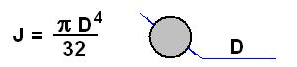
For a pipe, calculate J for the outside diameter, then SUBTRACT the J for the inside diameter (the hole).
We do not have torsion equations for square shapes - these equations only work for circular shapes (round rods and pipes). Anything else will deform under torsion and will not obey these formulas. Open shapes like a slit pipe can be almost as strong in bending as a closed pipe, but hundreds of times weaker in torsion.
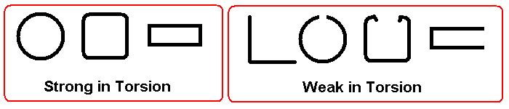
To measure torque, convert the mass to Newtons. (Take the mass in kg and multiply by 9.81 for gravity). Now multiply by the perpendicular distance to the axis of the rod to get torque in Nmm.
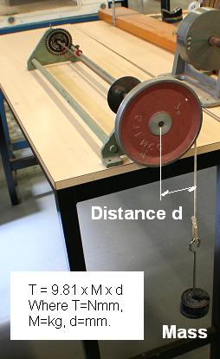

Errors
(Pre-requisite: Errors test Tester #11104_Errors. See notes on Error Analysis.)
Record the absolute error for each measurement: The absolute error is the sum of several factors:
Absolute error = (Resolution / 2) + (Parallax error) + (misalignment error) + (systematic error)
Where: Resolution Error = smallest increment in the measurement scale. The human limit is considered to be half of this again. For example, this dial gauge has smallest increment = 0.01mm, so it is considered to be readable to 0.005mm.
Parallax error is an error caused by viewing the meaurement at an angle. Parallax is an apparent displacement or difference of orientation of an object viewed along two different lines of sight. This is why the passenger in a car thinks you are going over the speed limit, but from the driver's view, the needle says the car is going the right speed! Parallax is avoided by looking straight-on, and also kept to a minimum by keeping the needle close to the scale. Your estimate of parallax error depends on the geomtery of the measurement, but for the gauge above the parallax error would be only about 10% of the increment.
Misalignment error: Not taking the measurement parallel or perpendicular. Eg.The dial gauge is not vertical, the tape measure is at an angle, the caliper is not perpendicular etc. This is not supposed to happen if you take the measurement carefully, but some meaurements are more difficult than others.
Systematic error: An error inherent in the measuring instrument itself. Eg a tape measure is inaccurate due to temperature change, or it is actually printed wrong! Hopefully this is not a problem, but the only way top check is to check the calibration against a known standard.

You must specify the absolute error when you state your answers.

Lab Notes
- Torsion Test (Word doc: 4 pages)

Relevant pages in MDME
- Mechanical Properties practice test: 10101cp
- Pre-requisite: Errors test Tester #11104_Errors. See notes on Error Analysis.

Web Links
- Links for information about scientific errors
http://instructor.physics.lsa.umich.edu/ip-labs/tutorials/errors/vocab.html
http://dwb.unl.edu/Teacher/NSF/C14/C14Links/www.chem.ualberta.ca/courses/plambeck/p101/p01017.htm
http://mathforum.org/library/drmath/view/61050.html

